TEAM NUMBER – 12

AKSHAT MISHRA- 19BCS009

AMAN KUMAR-19BCS115

SEJAL RAI-19BCS098

PRIYAM- 19BCS089

UATTAM KKUMAR JANGID- 19BCS108

NISHIKANT PRASAD – 19BCS079

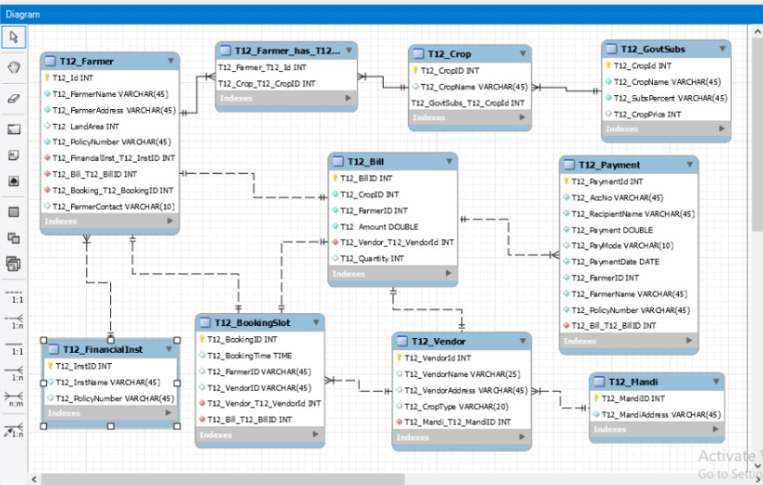

RELATIONSHIPS ARE AS FOLLOWS

T12Farmer – T12_ Crop M-N(weak)

T12_Crop – T12_GovtSubs M-1(weak)

T12_FARMER – T12_Bill 1-1(Strong)

T12_Bill – T12 _Payment 1-M(Strong)

T12_FARMER – T12 _FINANCIAL INSTITUTION M-1(STRONG)

T12_FARMER – T12_BOOKINGSLOT 1-1(STRONG)

T12_BILL – T12_BOOKING SLOT 1-1(STRONG)

T12_BOOKING SLOT -T12_VENDOR M-1(STRONG)

T12_BILL – T12_VENDOR 1-1(STRONG)

T12_VENDOR – T12_MANDI M-1(STRONG)